

**Be part of the largest zumbathon in Stockport and Support *Francis House***

**Sunday, June 9, 2013**

**1:30pm - 4:00pm**

***Tickets at the door: £15***

***Pre-Sale Tickets: £10 (ring - 07723693227 - 07756201380) or***

***Please return your £10 entry fee to: Francis House Children's Hospice Fundraising Office, 390 Parrswood Road, Didsbury, Manchester, M20 5NA, Registered Charity No 328659***

***Children Tickets: £5 (7-13)***

***Venue: Moor Suite***

***Location: 35 Heaton Moor Road, Heaton Moor, Stockport SK4 4PB***

***FOR MORE INFORMATION***

***07756201380/*** **0161 443 2200**

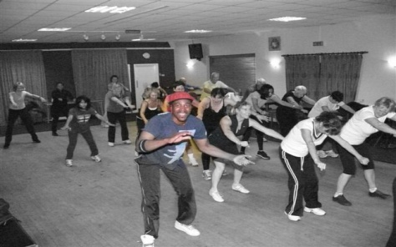

**Special Guest: Mauro Beca & Yosha Gilkes**